FORECASTING EGG PRICES IN THE USA

USING AN ARMA MODEL

A TIME SERIES ANALYSIS

# Introduction

## Why Do Egg Prices Matter?

The prices of eggs in the United States can indicate a range of factors:

* Inflation: Egg prices can be a measure of inflation, as they are a commonly consumed food item, and changes in their price can reflect changes in the overall price level of the economy.
* Market conditions: The prices of eggs can indicate the supply and demand conditions in the egg market. Higher prices may suggest that demand is exceeding supply, while lower prices may suggest that supply is outstripping demand.
* Production costs: The prices of eggs can reflect the cost of producing and distributing eggs. Increases in these costs can lead to higher egg prices, while decreases in these costs can lead to lower egg prices.
* Consumer behavior: Changes in the prices of eggs may reflect changes in consumer behavior, such as shifts in preferences for organic, cage-free, or other specialty eggs.
* Health and safety concerns: Outbreaks of diseases like avian influenza or salmonella in egg-producing regions can lead to reduced supply and higher prices due to increased costs associated with mitigating the outbreaks.

## What Influences the Prices of Eggs in the USA?

The prices of eggs are influenced by a range of factors, following are a few examples:

* Supply and Demand
* Production costs
* Seasonal demand
* Government policies
* Health concerns
* Consumer trends

# Data

The data that we have used for this project is the following:

* Data Type: Monthly Average of Egg Prices in the United States of America
* Duration: January 01, 2000 – March 01, 2023
* Frequency: Monthly
* Source: Federal Reserve Economic Database

# Exploratory Analysis

## Visualizing Original Time Series

First, we began by visualizing our original time series.

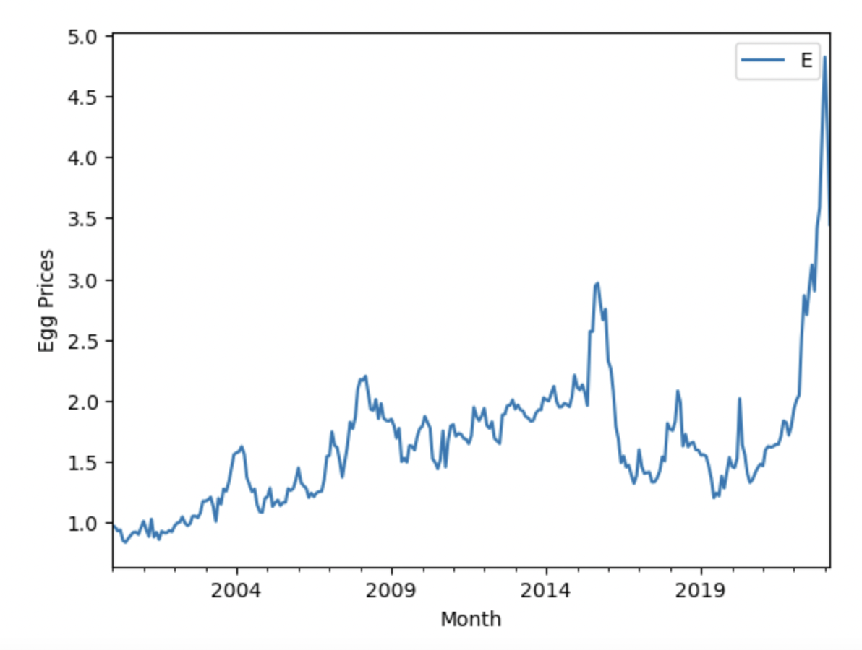

The spike in egg prices in 2019 was due to the surge in demand from China due to avian influenza (AI) and the resulting tight domestic supply, while the temporary increase in 2020 was due to pandemic-related disruptions in the supply chain.

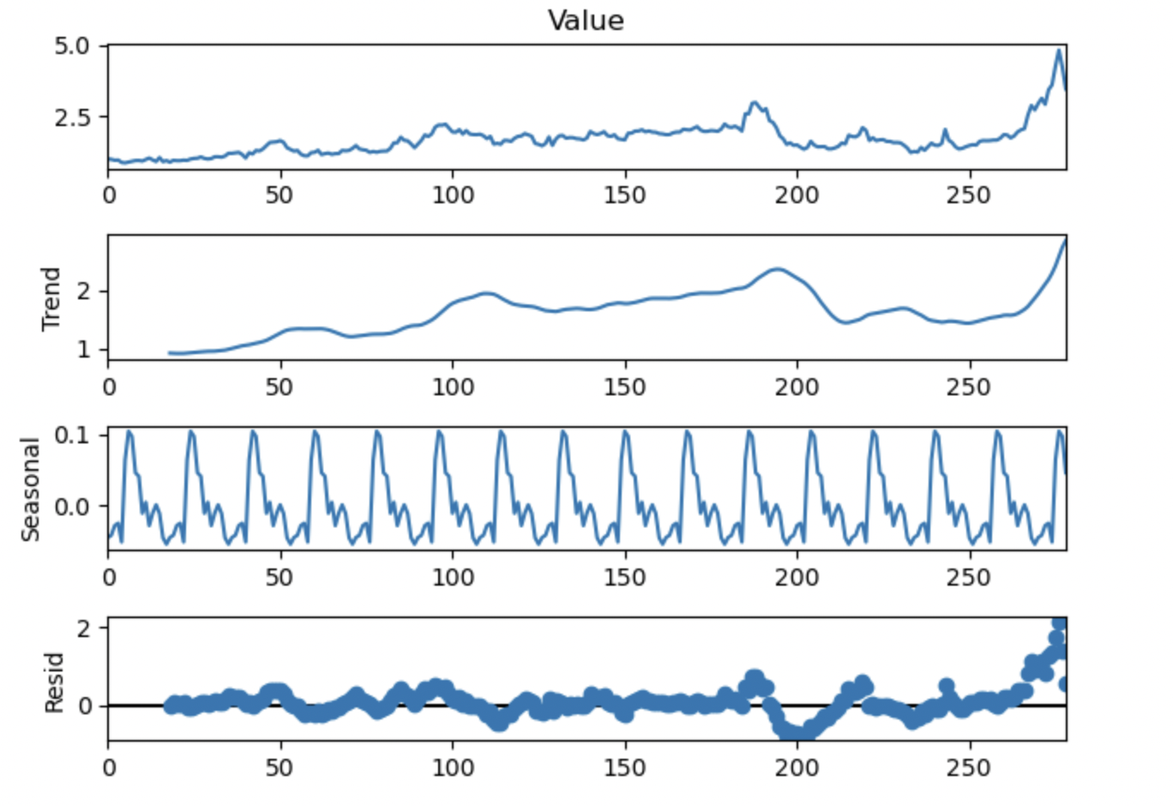

By examining the chart, we can observe clear patterns of trend and seasonality in the original data, which are typical indicators of a time series dataset. This suggests that the dataset we have selected is well-suited for time series analysis.

## Check Stationarity of Original Time Series

The ARMA model assumes that the statistical properties of the time series are constant over time, which is only true for stationary time series. Therefore, to estimate the parameters of an ARMA model, the time series data must be stationary.

The Dickey-Fuller test has the purpose of assessing the stationarity of a dataset. The null hypothesis of the Augmented Dickey-Fuller test posits the existence of a unit root, while the alternative hypothesis rejects the presence of such a root. We establish a confidence level of 95% and if the p-value falls below 5%, we can conclude that the dataset exhibits stationarity.

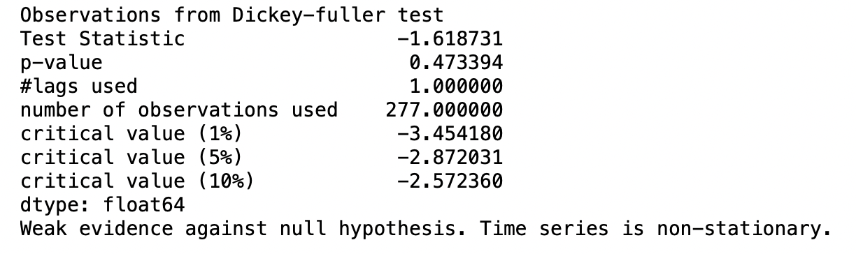

As shown above, the p-value for our original time series is greater than 0.05, which means that our original time series delineating egg prices in USA is not stationary.

# Train-Test Split

Now, we divide our data to an 80:20 split for the purpose of evaluating the performance of the ARMA model on unseen data. This is what our split looks like:

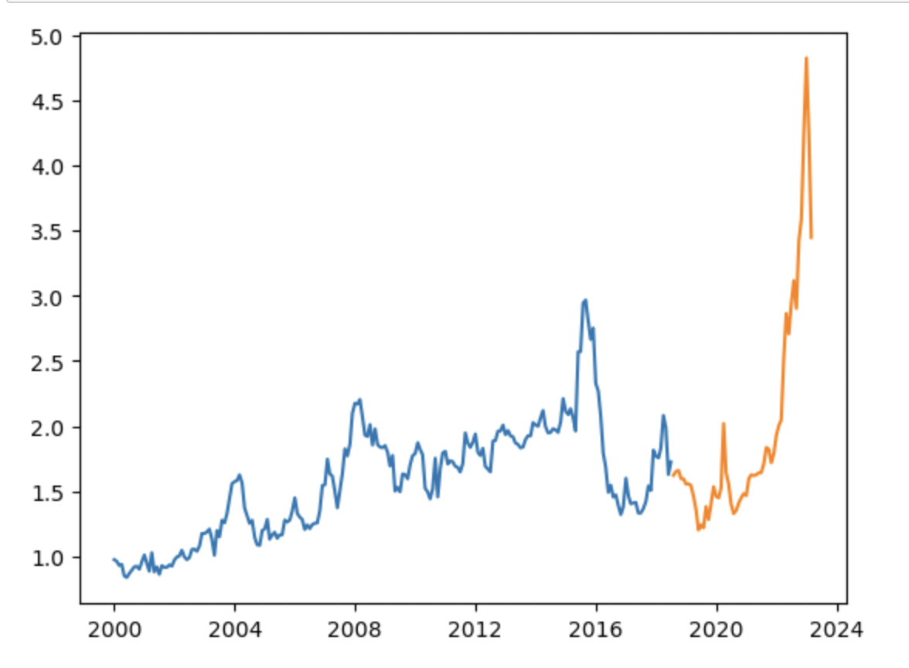

# Removing Trend and Seasonality from Time Series

## Detrending Method 1: Linear Trend

### Detrending using Linear Regression

* Linear regression is a statistical technique used to model the relationship between two variables by fitting a linear equation to the data.
* To detrend a time series using linear regression, we first plot the data and identify any linear trend present in the data.
* Once we have identified the trend, we can fit a linear regression model to the data, where the time variable is the independent variable, and the price variable is the dependent variable.
* The regression model estimates the slope and intercept of the line of best fit, which represents the trend in the data.
* By subtracting the predicted values of the regression line from the actual values, we can remove the trend from the data and obtain the residuals, which represent the random fluctuations around the trend.

The following is a visualization of our linear trend:

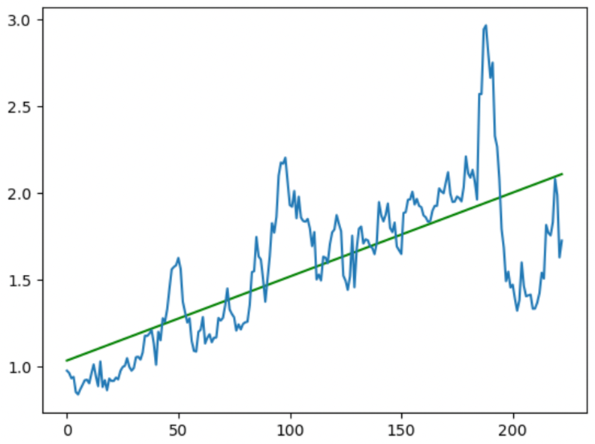

### Removing Seasonality from Detrended Data (Using Linear Trend)

We create a function that calculates the seasonal mean of a time series by computing the mean of the data for each season (e.g., month, quarter) and returning an array of these means. The function uses a loop to accumulate the sum and count of the data points for each season, and then computes the mean for each season by dividing the sum by the count. Finally, we obtained the seasonal mean for each data point by looking up the mean for the corresponding season in the array of seasonal means.

We get the resulting as follows:

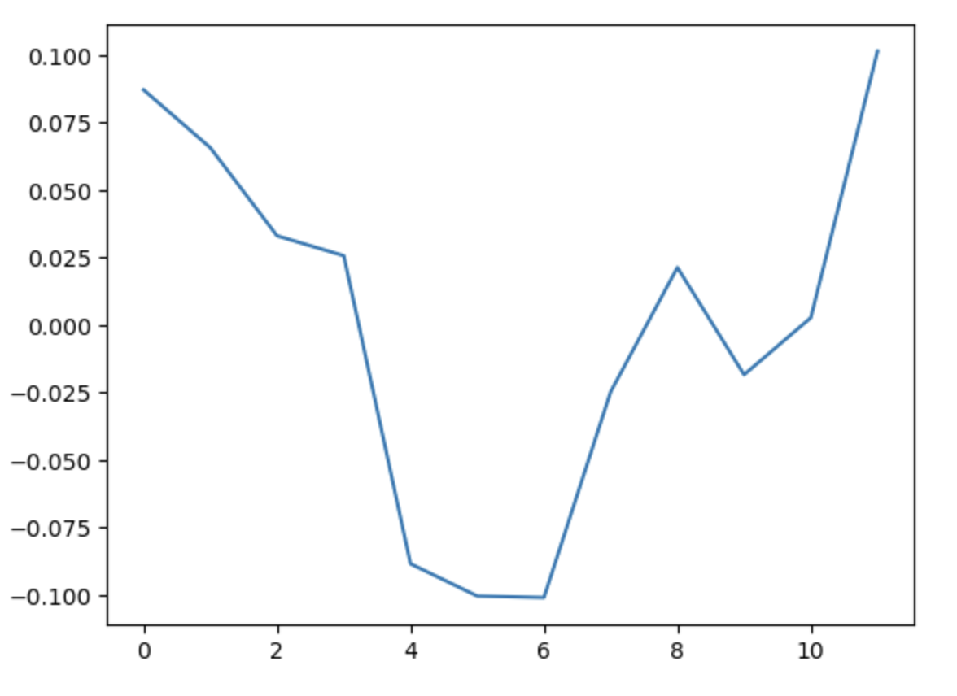

Thus, we see the obvious seasonality in the data: egg prices drop during the summer months when egg consumption is low and high during the winter months, festive season.

### Residuals after De-Trending and De-Seasonalizing

After we perform the above manipulations to remove trend and seasonality, we calculate the residuals from the manipulated data as follows:

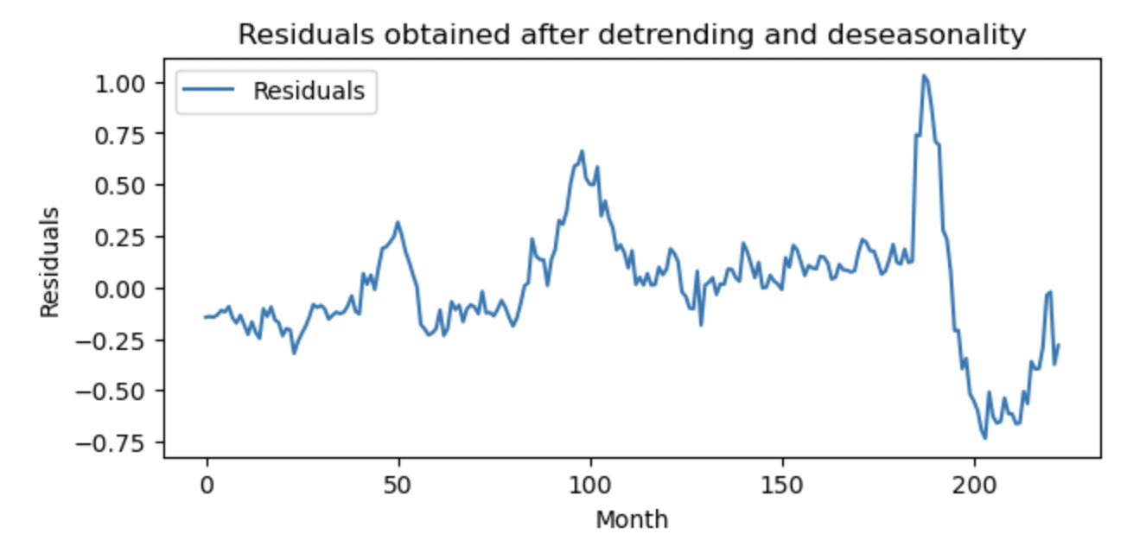

We will then use the Augmented Dickey-Fuller test to check the stationarity of the residuals from the manipulated time series.

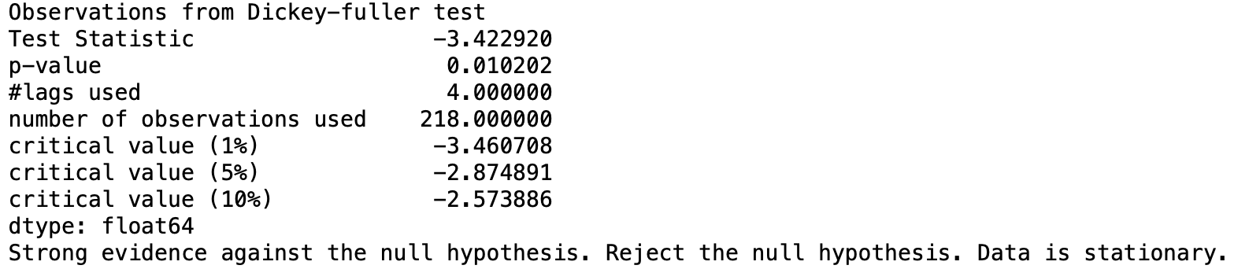

From the above, we can gauge that the p-value here is 0.01 which is less than 0.05 (5%), therefore the residuals of manipulated time series are stationary. Since the residuals are stationary, we can apply ARMA model on this.

## Detrending Method 2: Moving Average

### Detrending using Moving Average

* Moving average is a statistical technique used to smooth out short-term fluctuations in a time series data and identify trends.
* To determine a time series using moving average, we first calculate the moving average of the data by taking the average of a sliding window of data points, where the window size is usually determined by the frequency of the seasonality in the data.
* The moving average represents the trend in the data, and by subtracting the moving average from the actual data, we can obtain the residuals, which represent the random fluctuations around the trend.

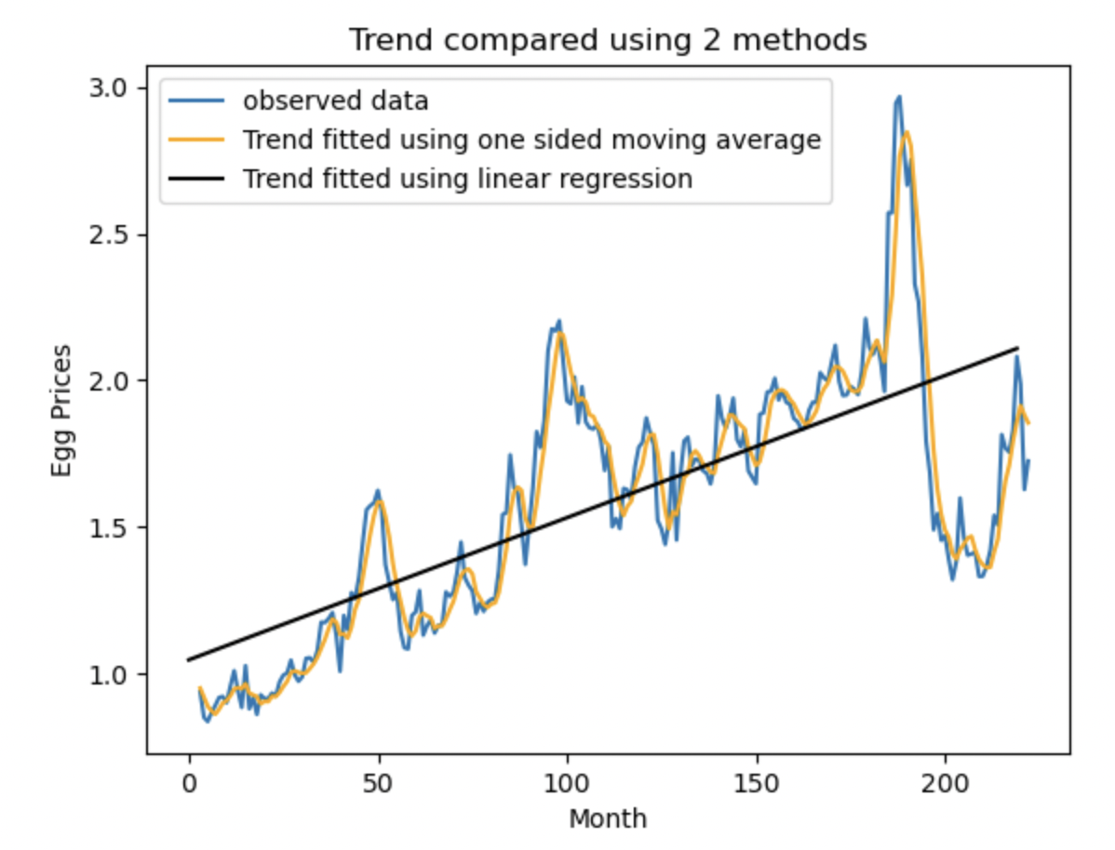

Thus, we see that the trend line is a better fit in case of Moving Average rather than Linear regression. MA de-trending would be a better option given that it does a better job capturing the minute jumps in the prices of eggs.

### Trend and Seasonality versus Observed Data

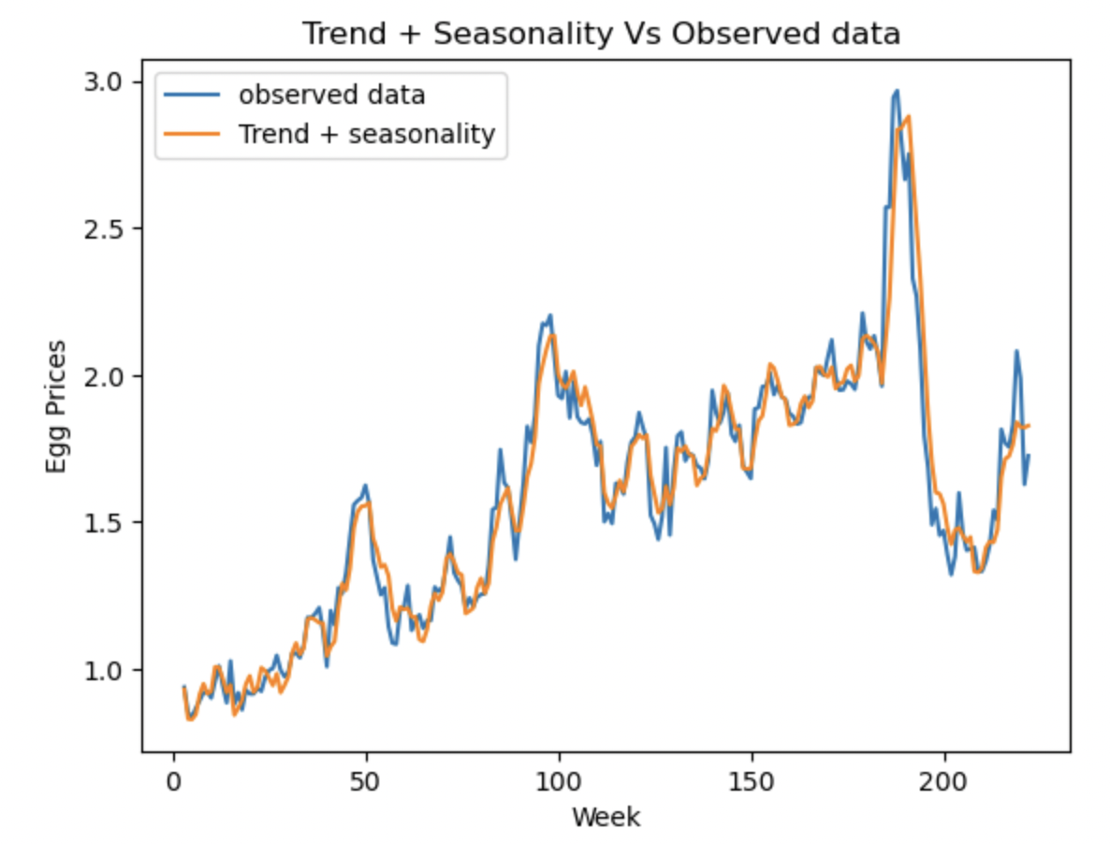

### Residuals after De-Trending and De-Seasonalizing

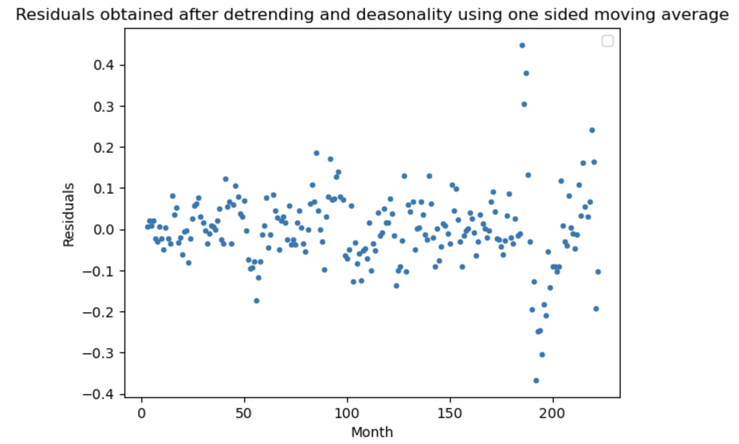

We will then use the Augmented Dickey-Fuller test to check the stationarity of the residuals from the manipulated time series.

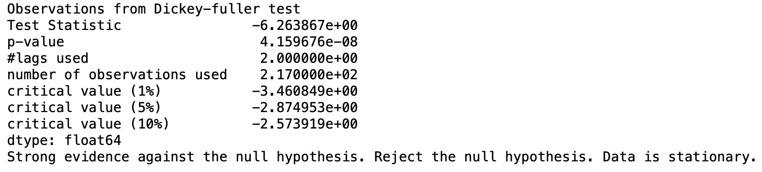

From the above, we can gauge that the p-value here is less than 0.05 (5%), therefore the residuals of manipulated time series are stationary. Since the residuals are stationary, we can apply ARMA model on this.

# Fitting the ARMA Model

## Using Residuals from Detrending Method 1: Linear Regression

We first needed to determine the parameters for our model. For that we obtained the ACF and PACF of our residuals. We started with our residuals of our detrended and de-seasoned data using Linear Regression.

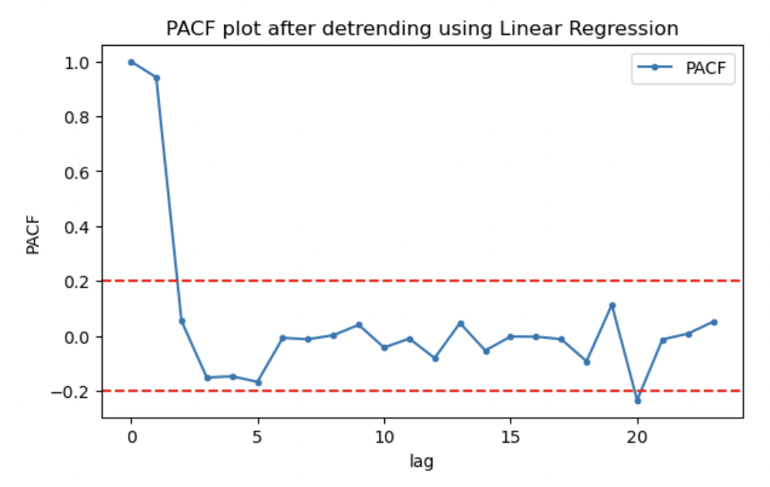

To identify the order of the AR model (i.e., the number of lagged values to include in the model), we look at the PACF plot. The AR model assumes that the current value of the time series is a weighted sum of its past values. So, we expect to see a decay in the PACF plot as the lag increases. The lag at which the PACF plot crosses the upper confidence interval for the first time is the order of the AR model. If the PACF plot shows a slow decay, it may indicate that the time series is not stationary, and we need to apply differencing before fitting the model.

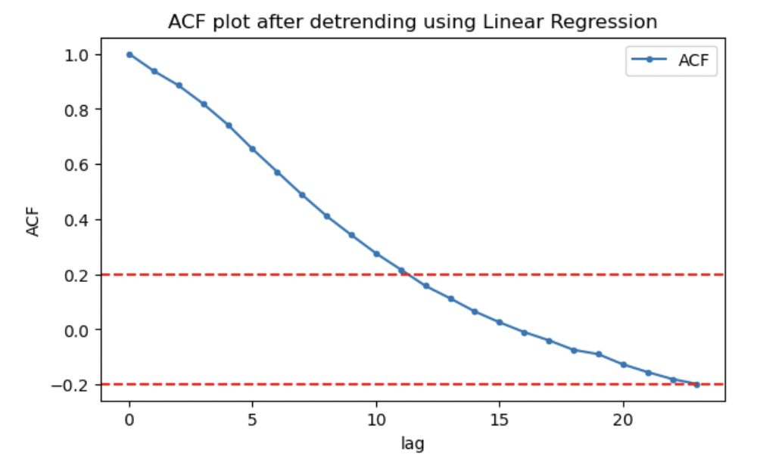

To identify the order of the MA model (i.e., the number of lagged errors to include in the model), we look at the ACF plot. The MA model assumes that the current value of the time series is a weighted sum of its past errors. So, we expect to see a decay in the ACF plot as the lag increases. The lag at which the ACF plot crosses the upper confidence interval for the first time is the order of the MA model.

Based on that analysis, we have decided to proceed with an ARMA model with one autoregressive component and eleven moving-average components.

### In-Sample fitting

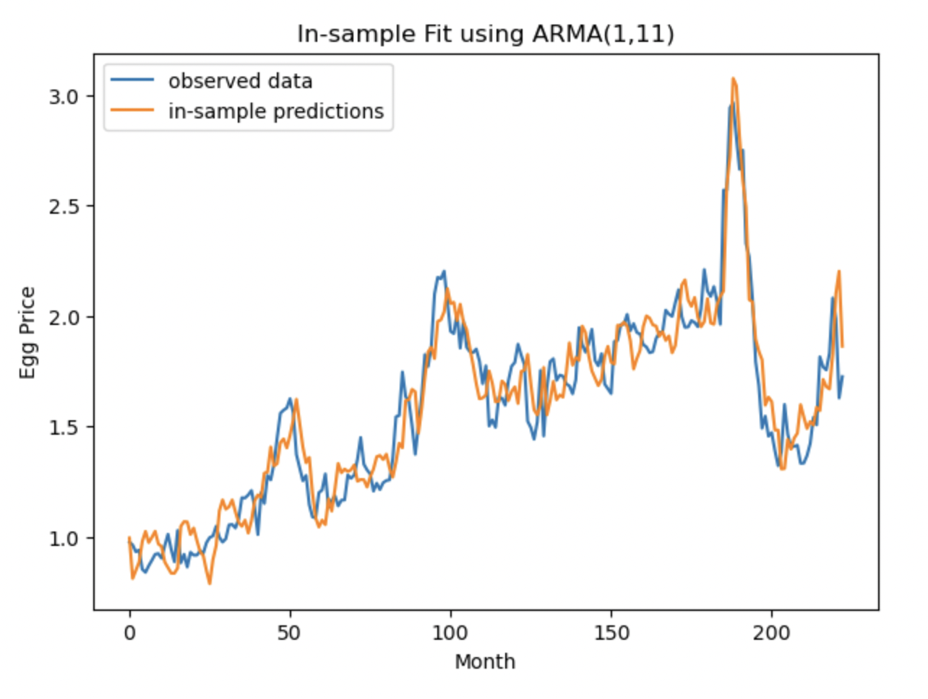

We have trained the model using the residuals after detrending and de-seasonalizing. We then forecasted noise for the period in the training sample and added back the trend and seasonality. As expected, the model performs well at predicting In-Sample, as seen on the graph.

### Out-of-Sample prediction

When predicting Out-Of-Sample, the model does not perform well. This could be due to the sudden increase in Egg Prices due to the pandemic, which was an external factor that a time series forecasting model could not have predicted.

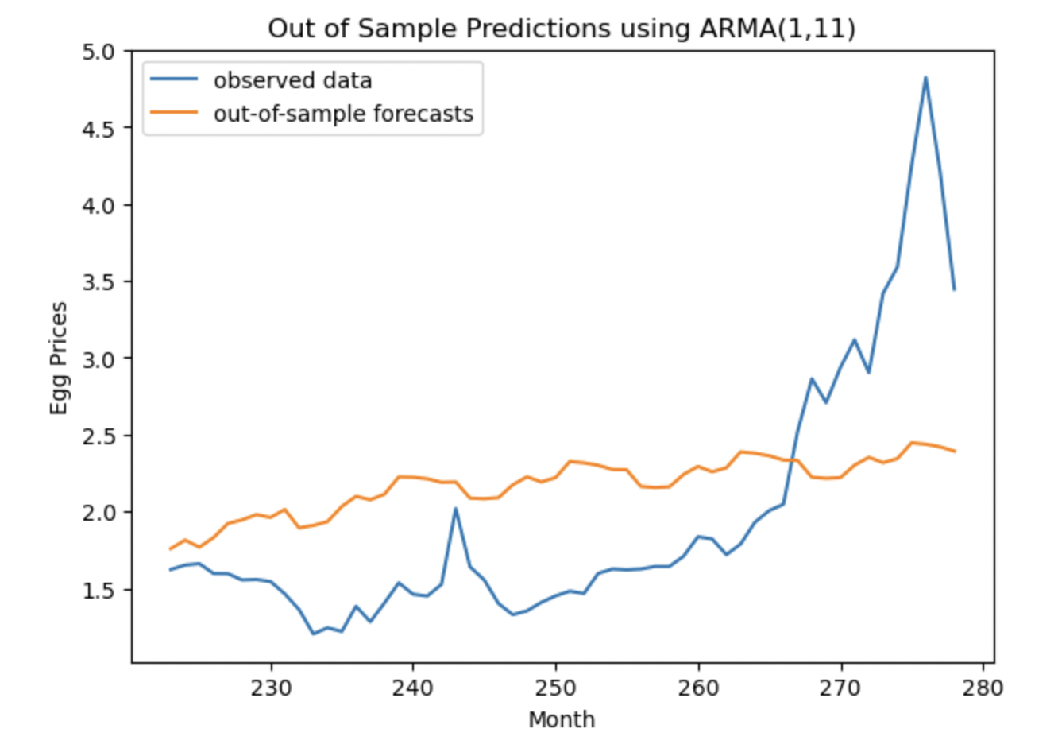

### Error Analysis

The performance metric that we have chosen is the Mean Square Error. This metric takes the average of the square of the difference between the data and the predicted values. We chose this metric because squaring the differences gives more importance to big errors or differences between the data and what the model has forecasted. In the case of the ARMA(1,11) model, the MSE that we obtained was approximately 0.63.

## Using Residuals from Detrending Method 2: Moving Average

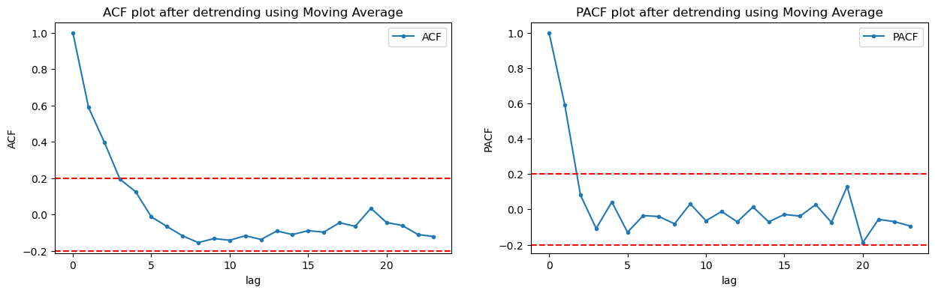

We manufactured another model, using the same method to obtain parameters as before, from the ACF and PACF. This time, we did the ACF and PACF using residuals of the data detrended using moving averages.

### In-Sample Fitting

As we can see, the model does a fantastic job at predicting In-Sample data, as this is the data with which it was trained.

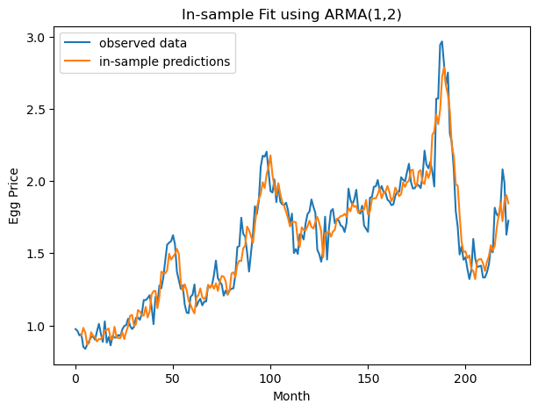

### Out-of-Sample prediction

In the case of Out-of-Sample prediction, the results look much better than the first model, except for the pandemic period. As shown on the next graph.

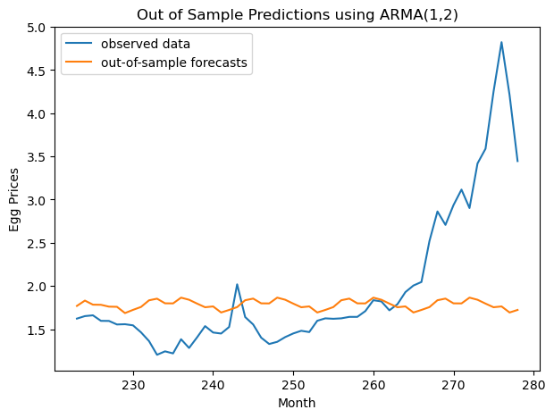

This could mean that the model performs better, but at the sudden appearance of an external factor, the predictions would continue with the expected behavior.

### Error Analysis

In this case the MSE for the out-of-sample predictions was 0.74. The increase can be explained by the nature of the metric, which squares the differences between the predictions and the actual data. Therefore, even though the model performs better than before at predicting values before the pandemic, the metric gives more importance to the magnitude of the error during the pandemic. Due to this, the performance metric is higher than before.

# Enhancements

We will now show how we did the same process, but with a logarithmic value of the time series.

## Visualizing Log Time Series

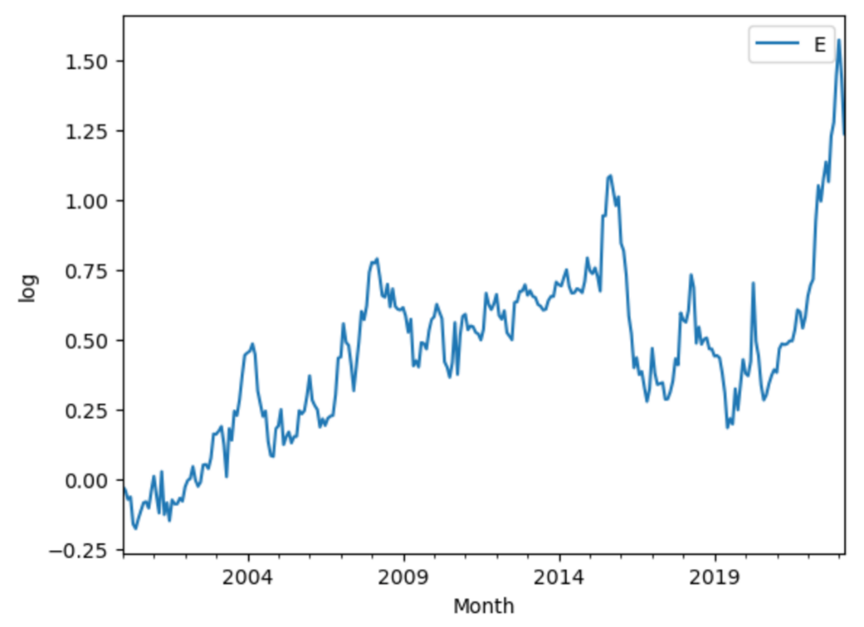

We then decompose data into its value, trend, seasonality, and residuals.

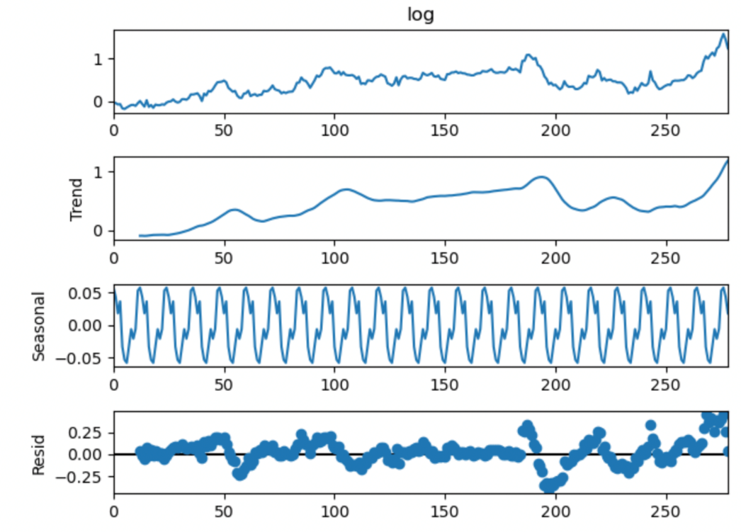

## Check Stationarity of Log Time Series

We perform the Augmented Dickey-Fuller test to check the stationarity of the log time series. The result obtained are as follows:

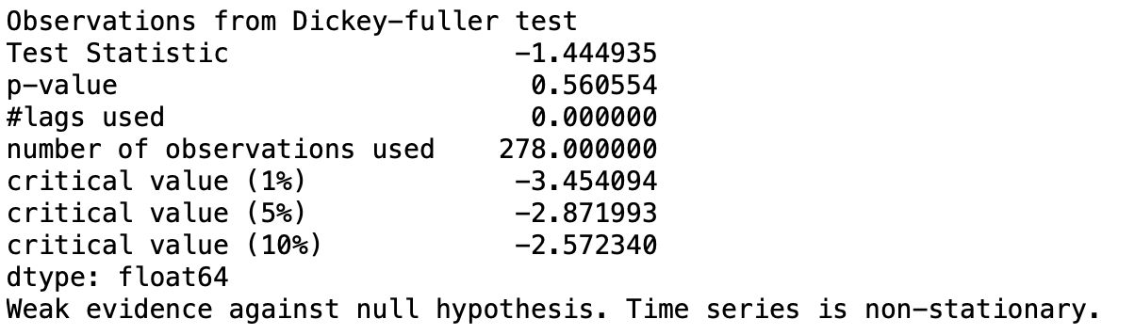

As shown above, the p-value for our log time series is greater than 0.05, which means that our log time series is not stationary.

## Train-Test Split

We divide the log time series into an 80-20 split for the purpose of evaluating the performance of the ARMA model on unseen data. This is what our split looks like:

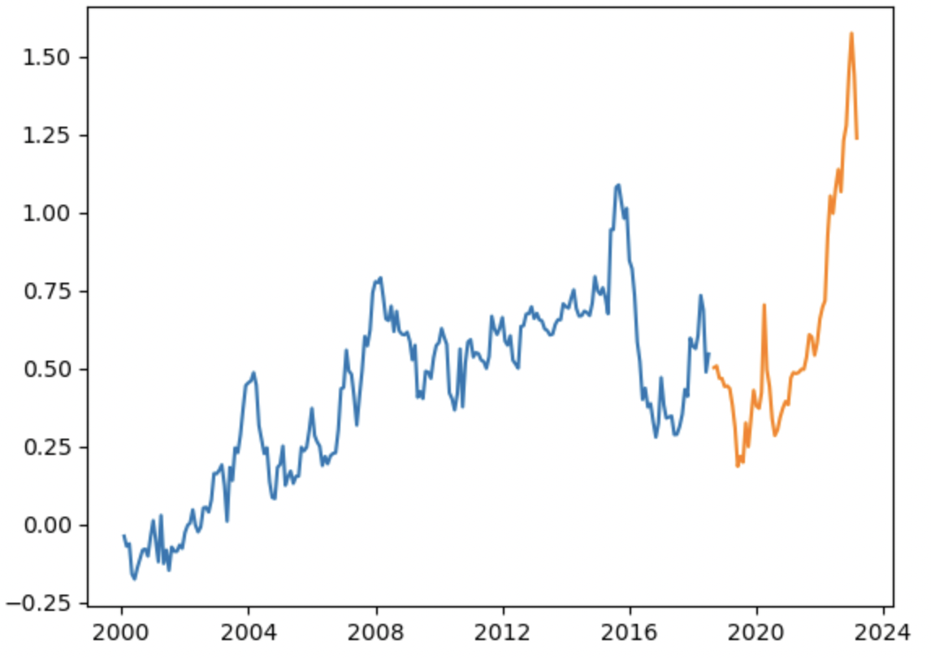

## Detrending Method 1: Linear Trend

We get the following from detrending using Linear Regression:

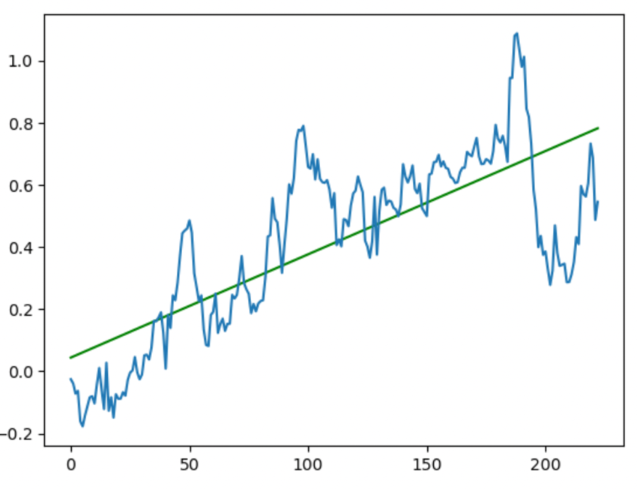

We get the following seasonality:

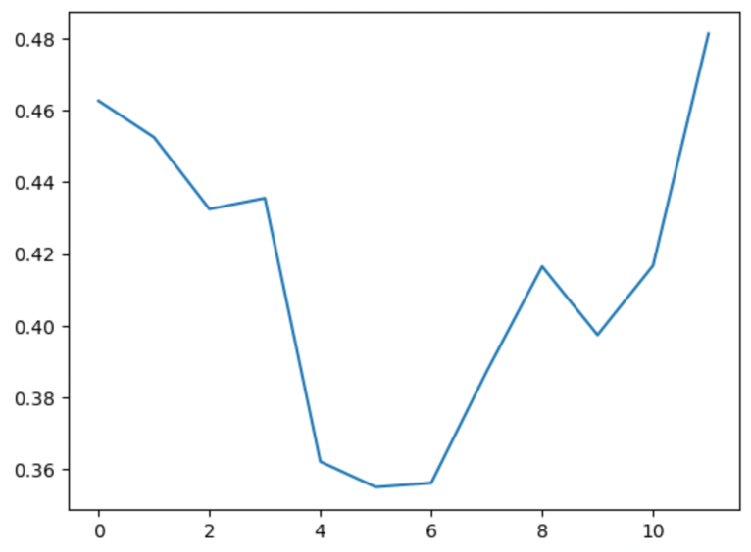

Furthermore, the residuals obtained from performing the above manipulations on the log time series are as follow:

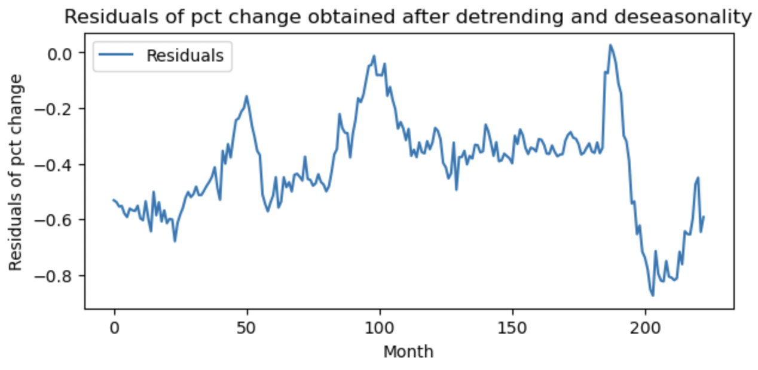

We then used the Augmented Dickey-Fuller test to check the stationarity of the residuals from the manipulated log time series.

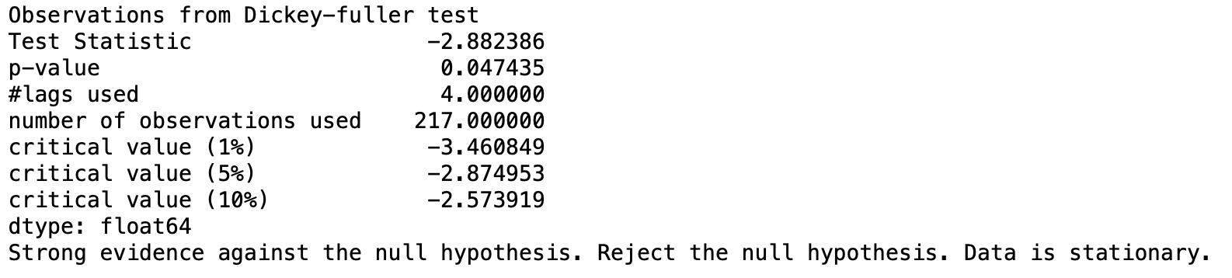

From the above, we can gauge that the p-value here is 0.047 which is less than 0.05 (5%), therefore the residuals of manipulated time series are stationary. Since the residuals are stationary, we can apply ARMA model on this.

## Detrending Method 2: Moving Average

Comparing the two trends obtained by using the two methods on log time series:

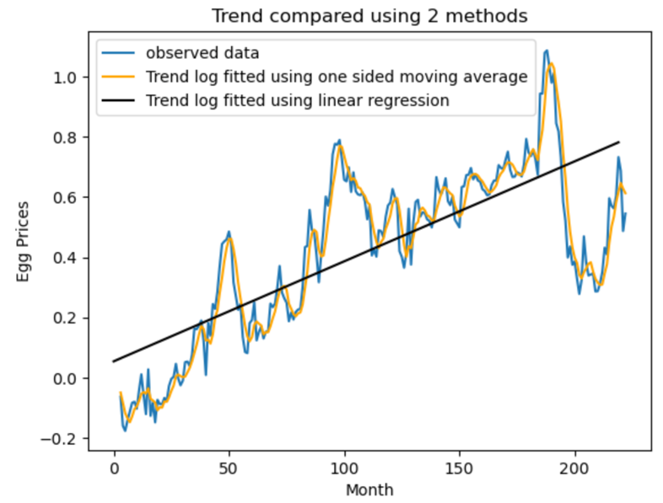

### Trend and Seasonality versus Observed Data for Log Time Series

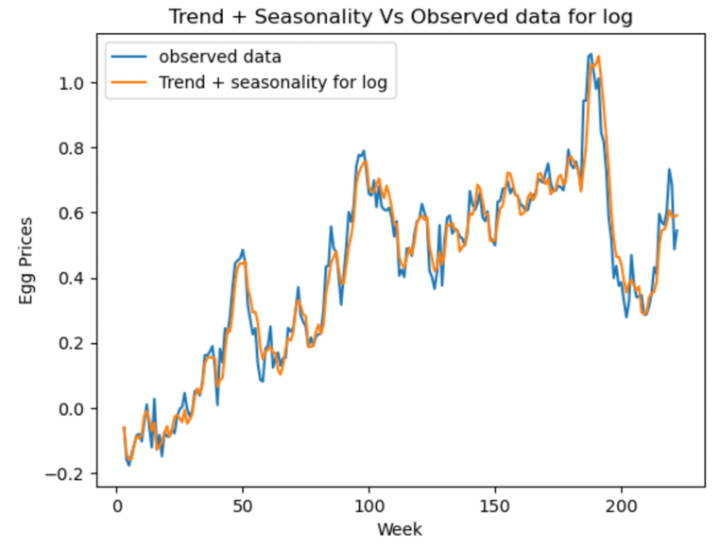

### Residuals after De-Trending and De-Seasonalizing for Log Time Series

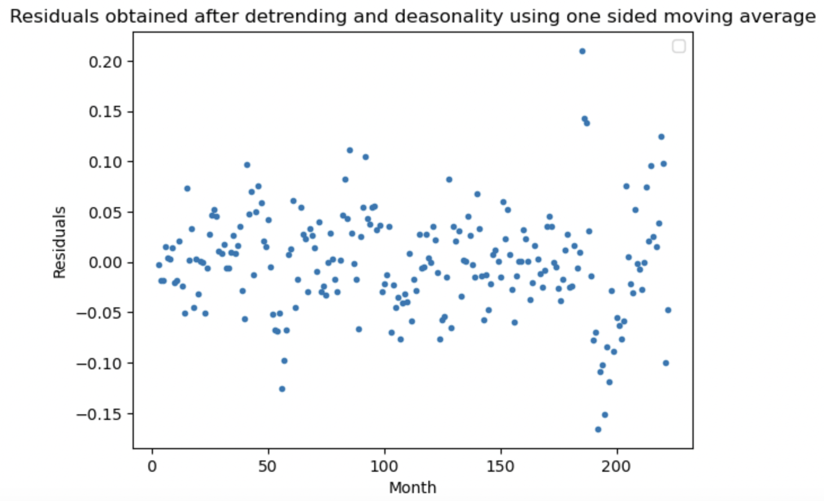

We will then use the Augmented Dickey-Fuller test to check the stationarity of the residuals from the manipulated time series.

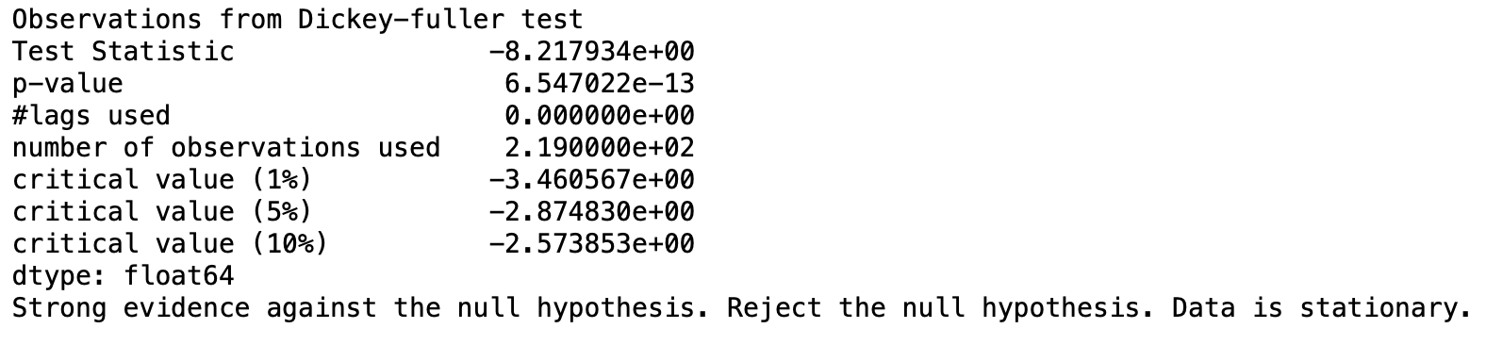

From the above, we can gauge that the p-value here is less than 0.05 (5%), therefore the residuals of manipulated time series are stationary. Since the residuals are stationary, we can apply ARMA model on this.

## Fitting ARMA Model on Log Time Series

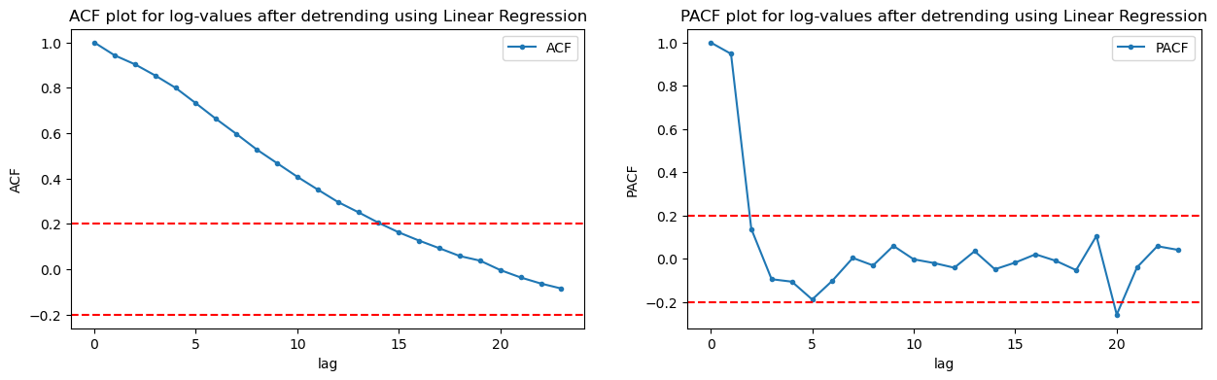

We manufactured a model trained with residuals from the log-values, and that were detrended using the Linear Regression. Using the same method as before, where we obtained information for the model based on the ACF and PACF graphs, we concluded that the model we were going to use was an ARMA(1,13).

### In-Sample Fitting

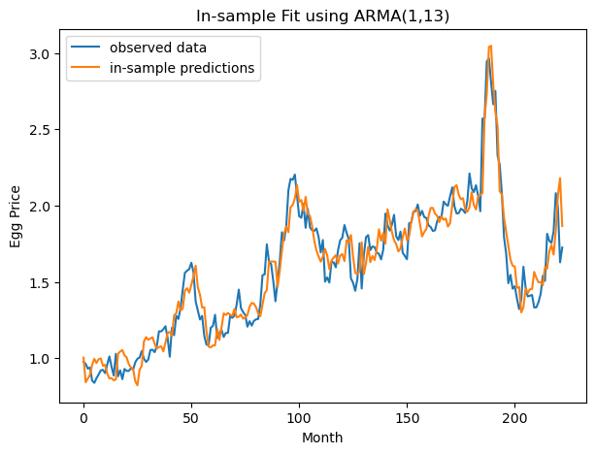

Using the same method as before, we forecasted noise using our model, and added back the trend and seasonality. The performance, as expected, fits well In-Sample, as this was our training data.

### Out-of-Sample predictions

When predicting Out-of-Sample data, we encountered the same issue as before for the start of the pandemic.

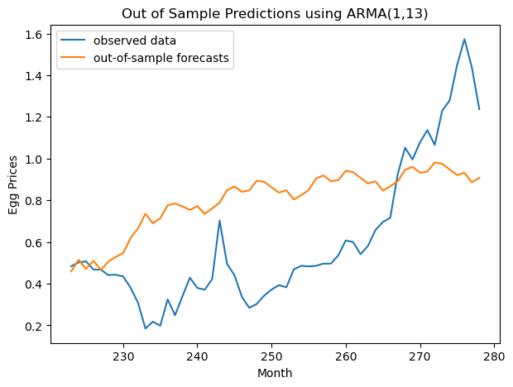

### Error Analysis

In this case the MSE was much lower (0.13). But we don’t have to confuse this measure with a sudden increase in the performance of our model. The reason the MSE is much lower is because we have reduced the magnitude of our data when we applied the logarithm. This makes the differences smaller in magnitude, but relatively they have stayed the same, as shown on the graph for Out-of-Sample predictions.